**Infocus Studio Ltd USSD application**

* First step the client will create the account to access the system
* 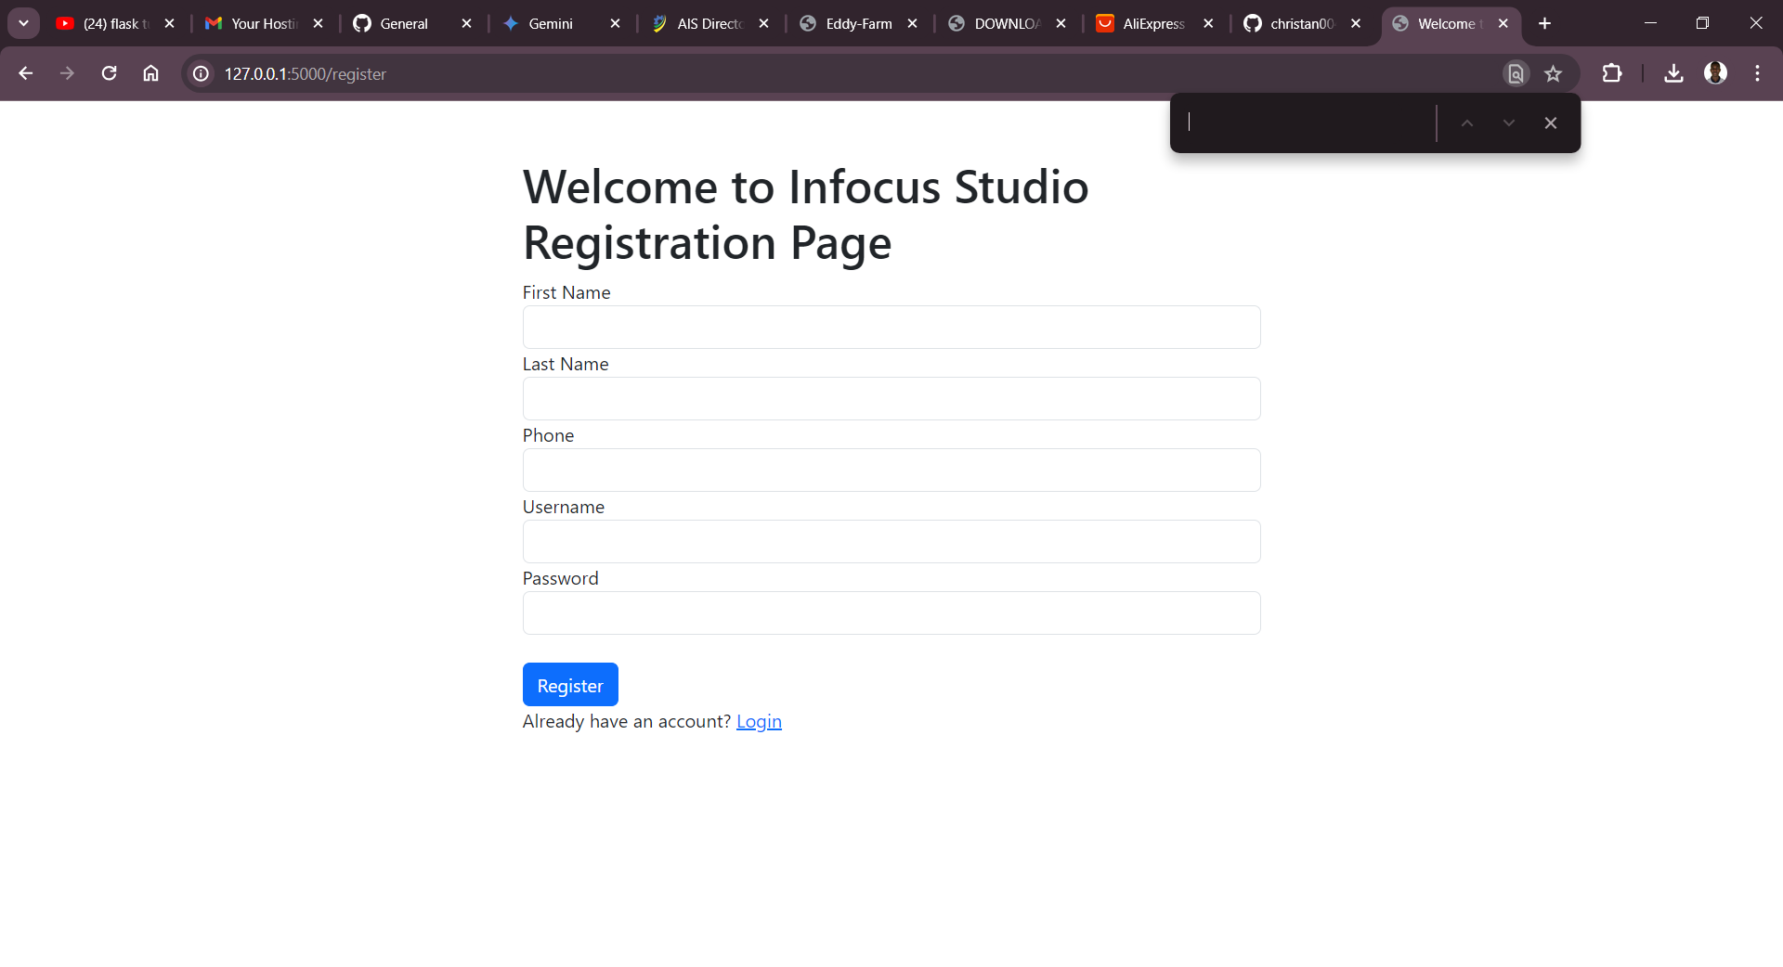
* After the user must to login to start using the system
* 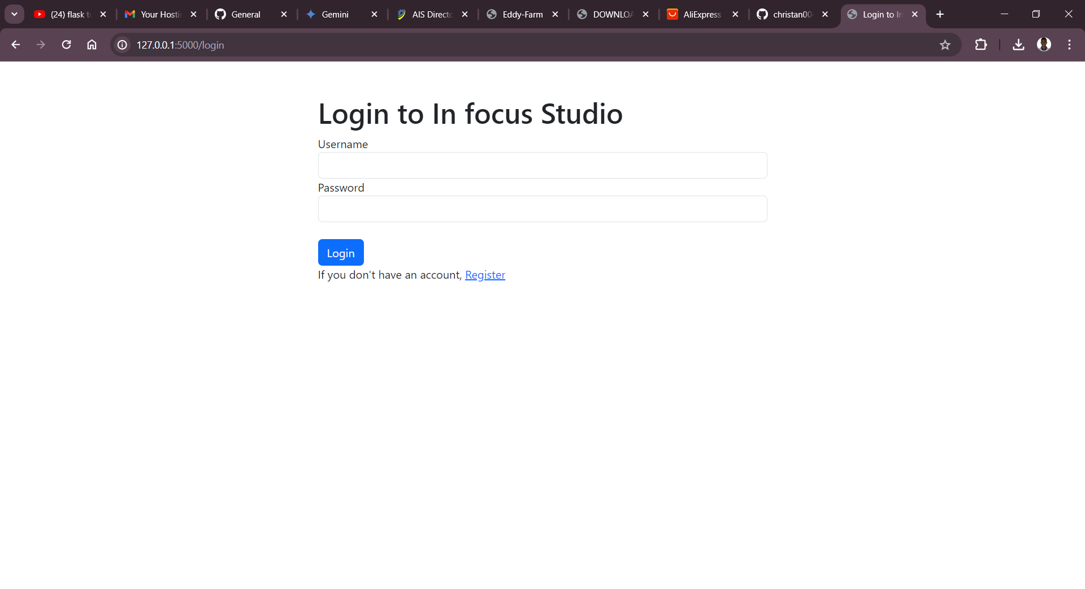
* After longing in the system the user will found on menu the tap that will let him or her book her service
* 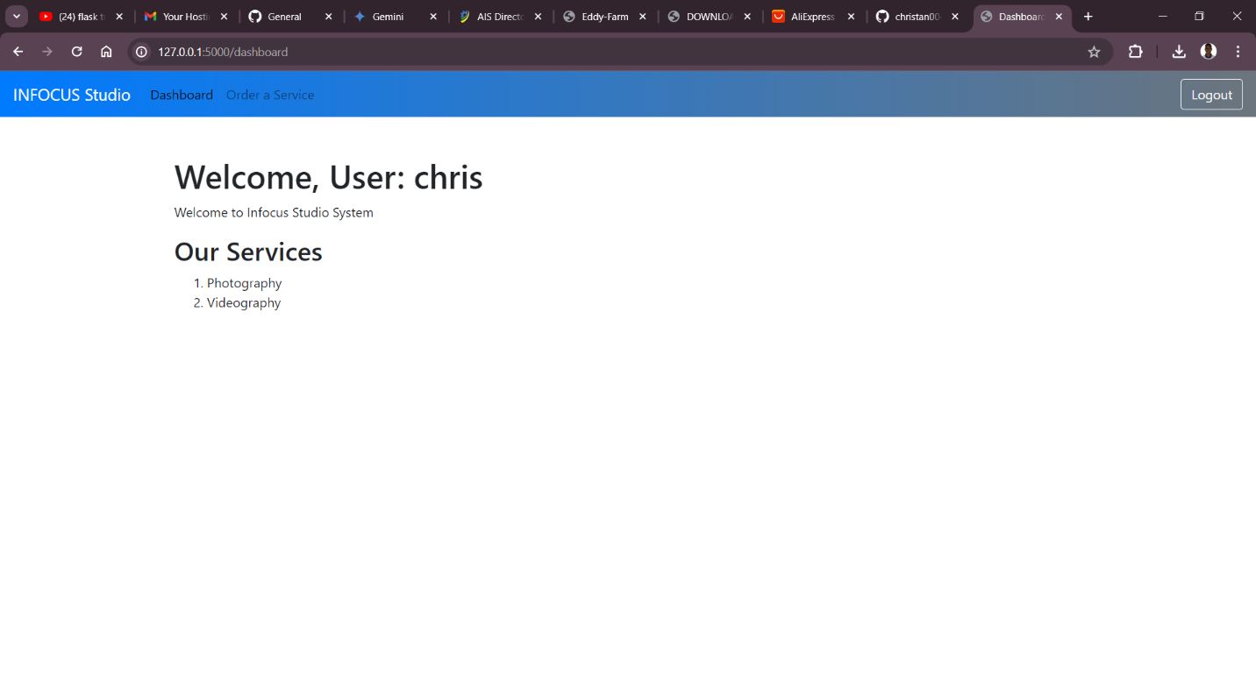
* 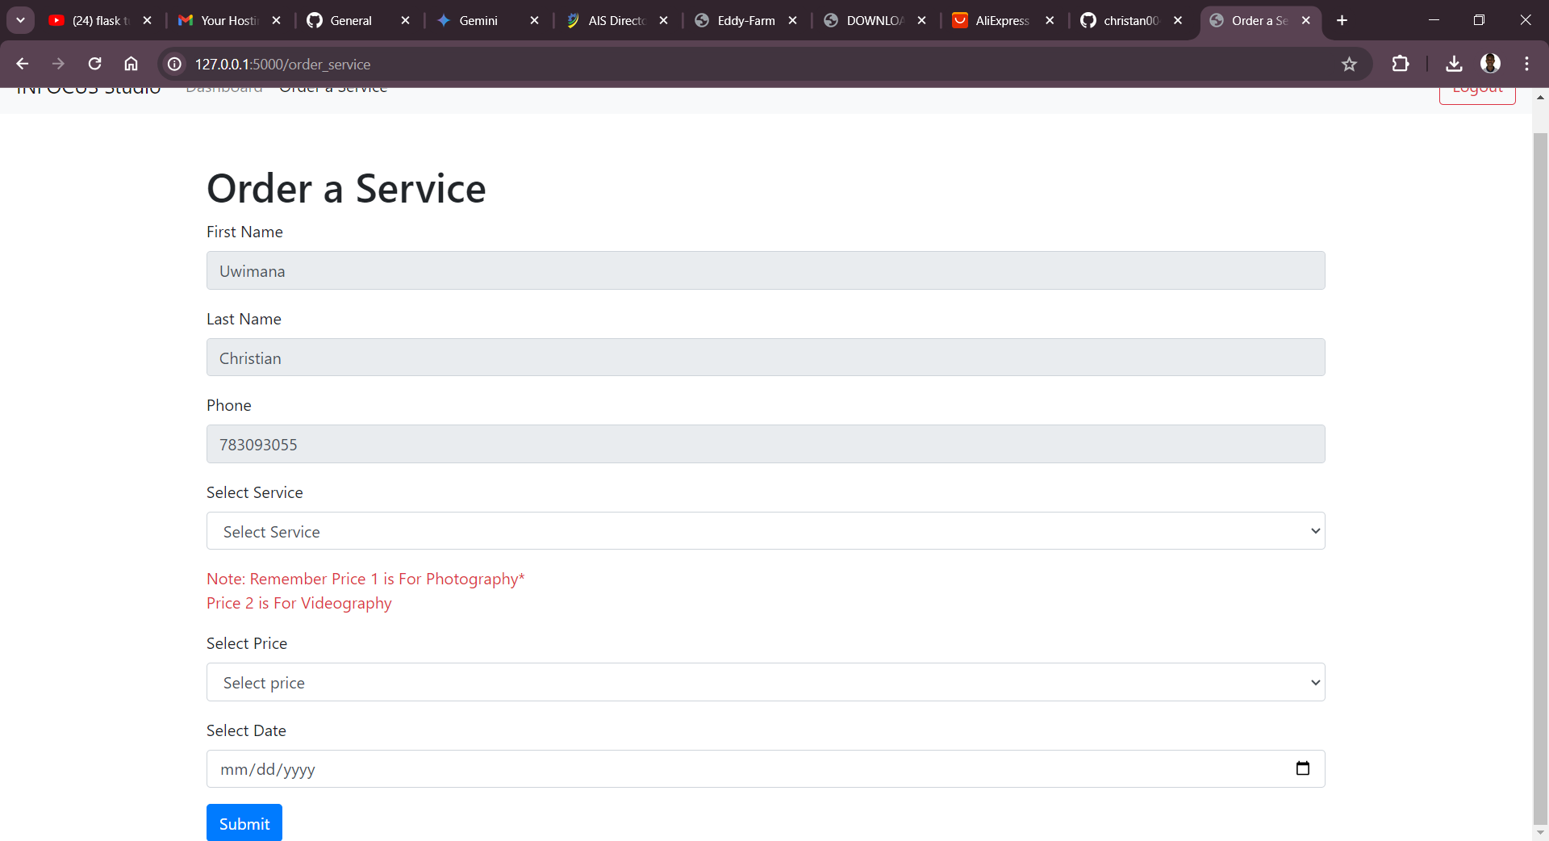
* After accessing those service he/she can make logout
* 